**Top Quark Initial State Classification**

**Aim:** Classifying quark-antiquark initial state top-quark anti-top-quark events from gluon-gluon fusion initial states

**Helpful review sources:**

[A Living Review of Machine Learning for Particle Physics | HEPML-LivingReview](https://iml-wg.github.io/HEPML-LivingReview/)

**Attempt 1: XGBoost**

XGBClassifier(base_score=0.5, booster='gbtree', colsample_bylevel=1,

colsample_bynode=1, colsample_bytree=1, enable_categorical=False,

gamma=0, gpu_id=-1, importance_type=None,

interaction_constraints='', learning_rate=0.001, max_delta_step=0,

max_depth=7, min_child_weight=1, missing=nan,

monotone_constraints='()', n_estimators=300, n_jobs=8,

num_parallel_tree=1, predictor='auto', random_state=0,

reg_alpha=5, reg_lambda=1, scale_pos_weight=1, subsample=1,

tree_method='exact', validate_parameters=1, verbosity=None)

**Results:**

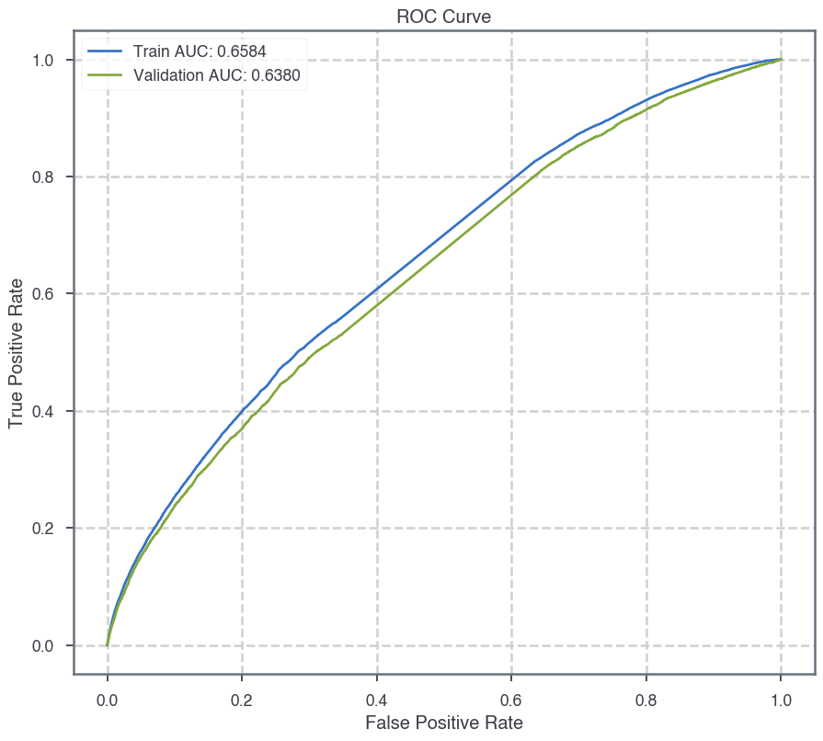

**Attempt 2 (Higher-dimensional input): XGBoost**

XGBClassifier(base_score=0.5, booster='gbtree', colsample_bylevel=1,

colsample_bynode=1, colsample_bytree=1, enable_categorical=False,

gamma=0, gpu_id=-1, importance_type=None,

interaction_constraints='', learning_rate=0.01, max_delta_step=0,

max_depth=5, min_child_weight=1, missing=nan,

monotone_constraints='()', n_estimators=300, n_jobs=8,

num_parallel_tree=1, predictor='auto', random_state=0,

reg_alpha=10, reg_lambda=1, scale_pos_weight=1, subsample=1,

tree_method='exact', validate_parameters=1, verbosity=None)

**Results:**

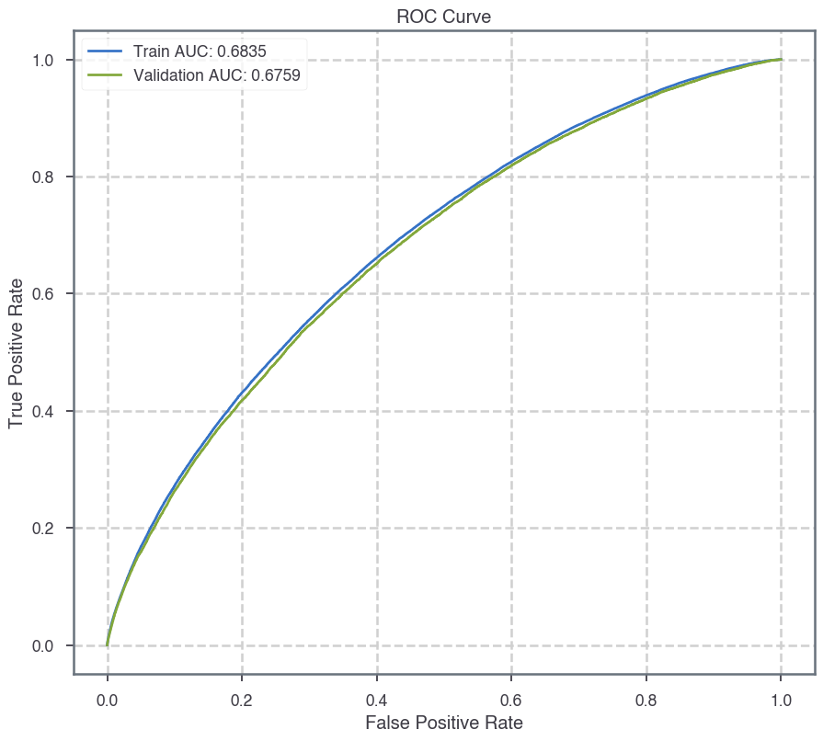

**Attempt 3 (Higher-dimensional input): DNN with L1 norm regularization**